DiaMetrics — Website UI and Run Instructions
Midpoint checkpoint deliverable (3 points): photos of the running Streamlit UI and instructions to run the code.

1. Website UI — real screenshots of the running Streamlit app
All screenshots captured from the live Streamlit app running against the cleaned BRFSS 2024 dataset (diabetes_dataset.csv, n = 100,520).

Page 1 — Personal Risk Calculator
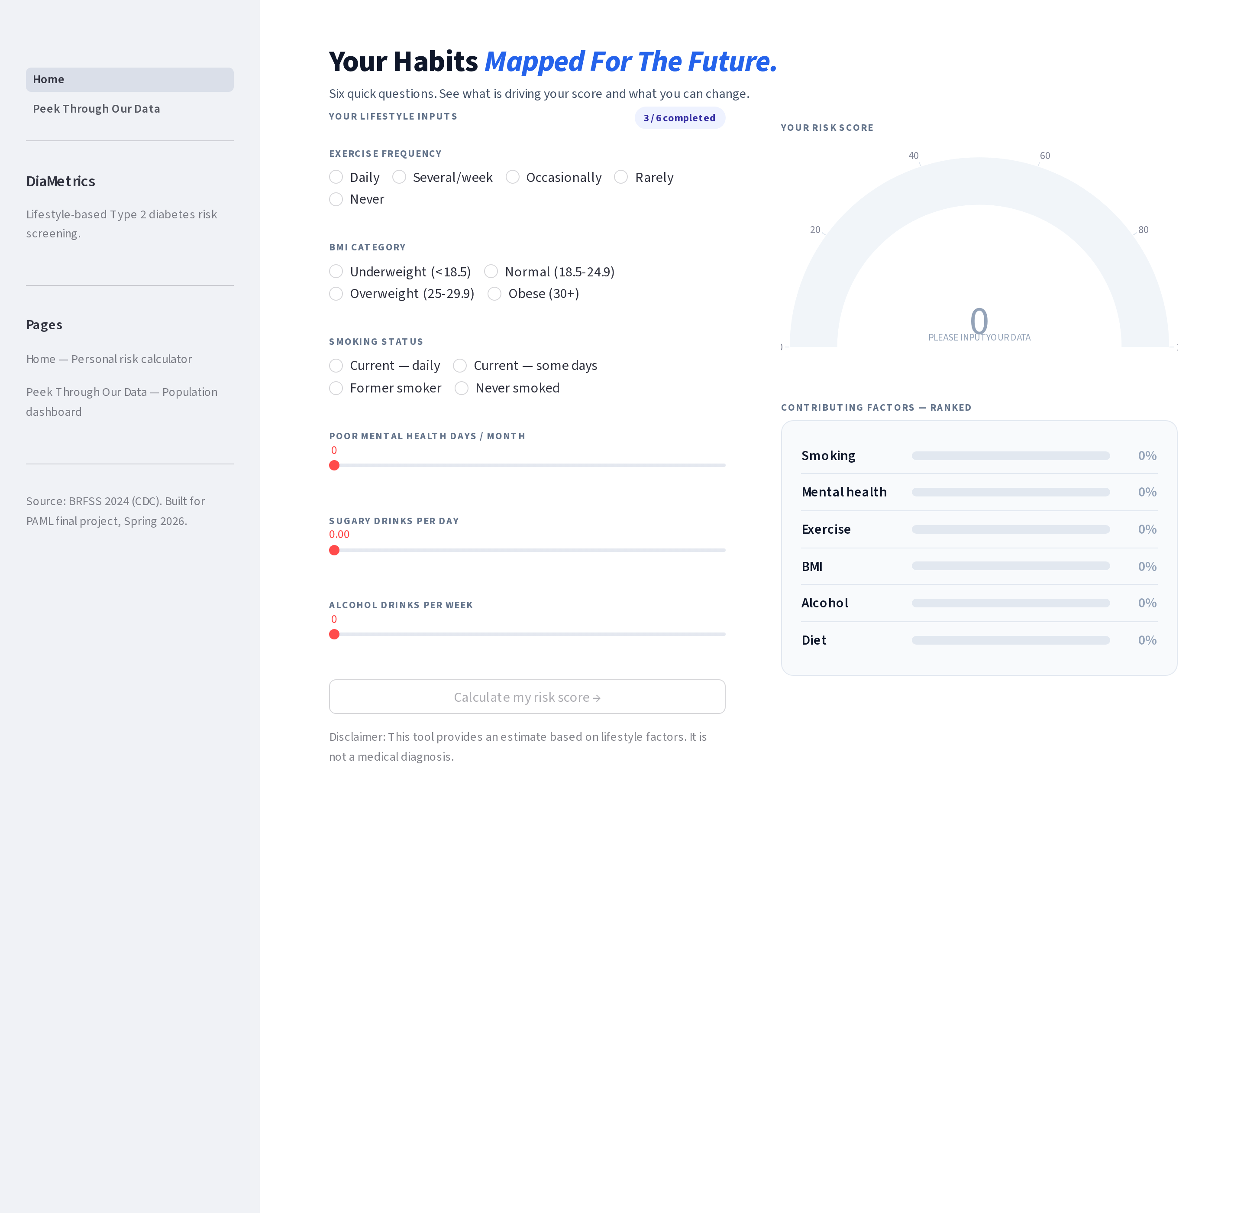
Fig 1. Page 1 landing state. Radio groups unselected, sliders at default 0. Gauge prompts the user to input their data.
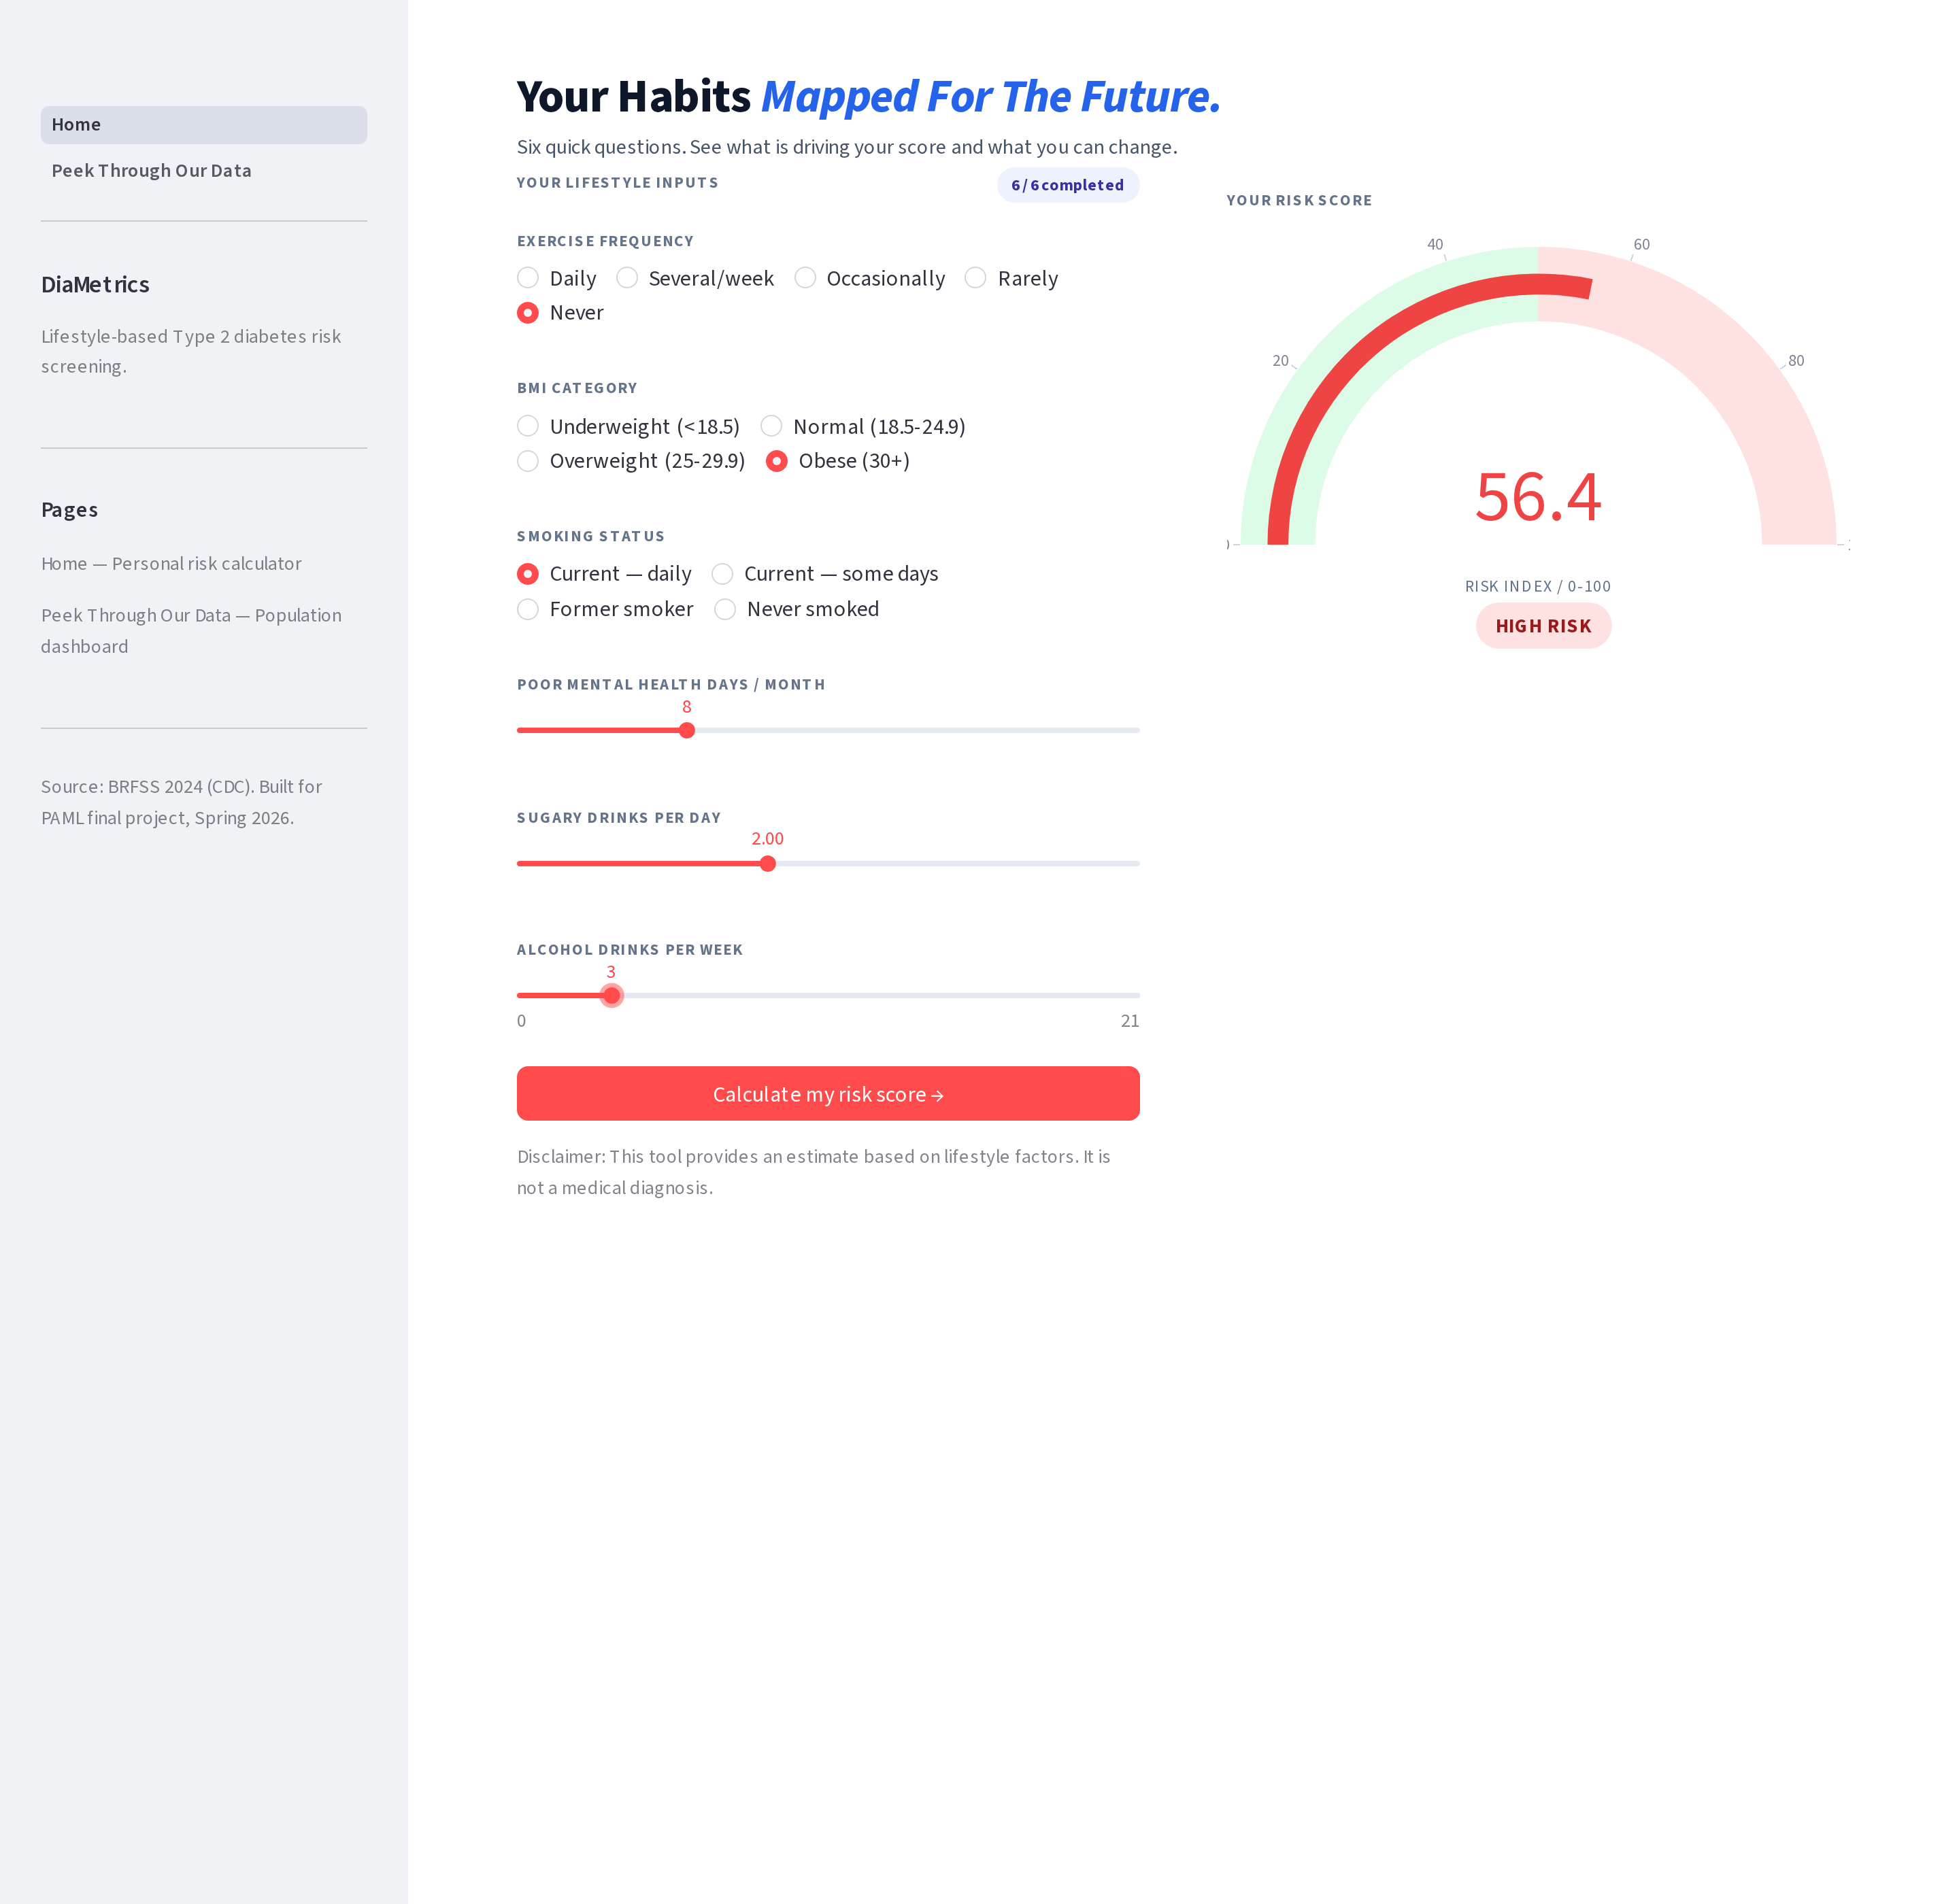
Fig 2. Page 1 filled. High-risk profile (Never exercises, Obese, Daily smoker, bad mental-health days, sugary drinks, alcohol) → 56.4 / 100 with a binary red High Risk pill (≥ 50 = red High Risk, < 50 = green Low Risk). Score is produced by Max’s final Logistic Regression (oversampling-trained, 64.67 % test accuracy).

Page 2 — Peek Through Our Data
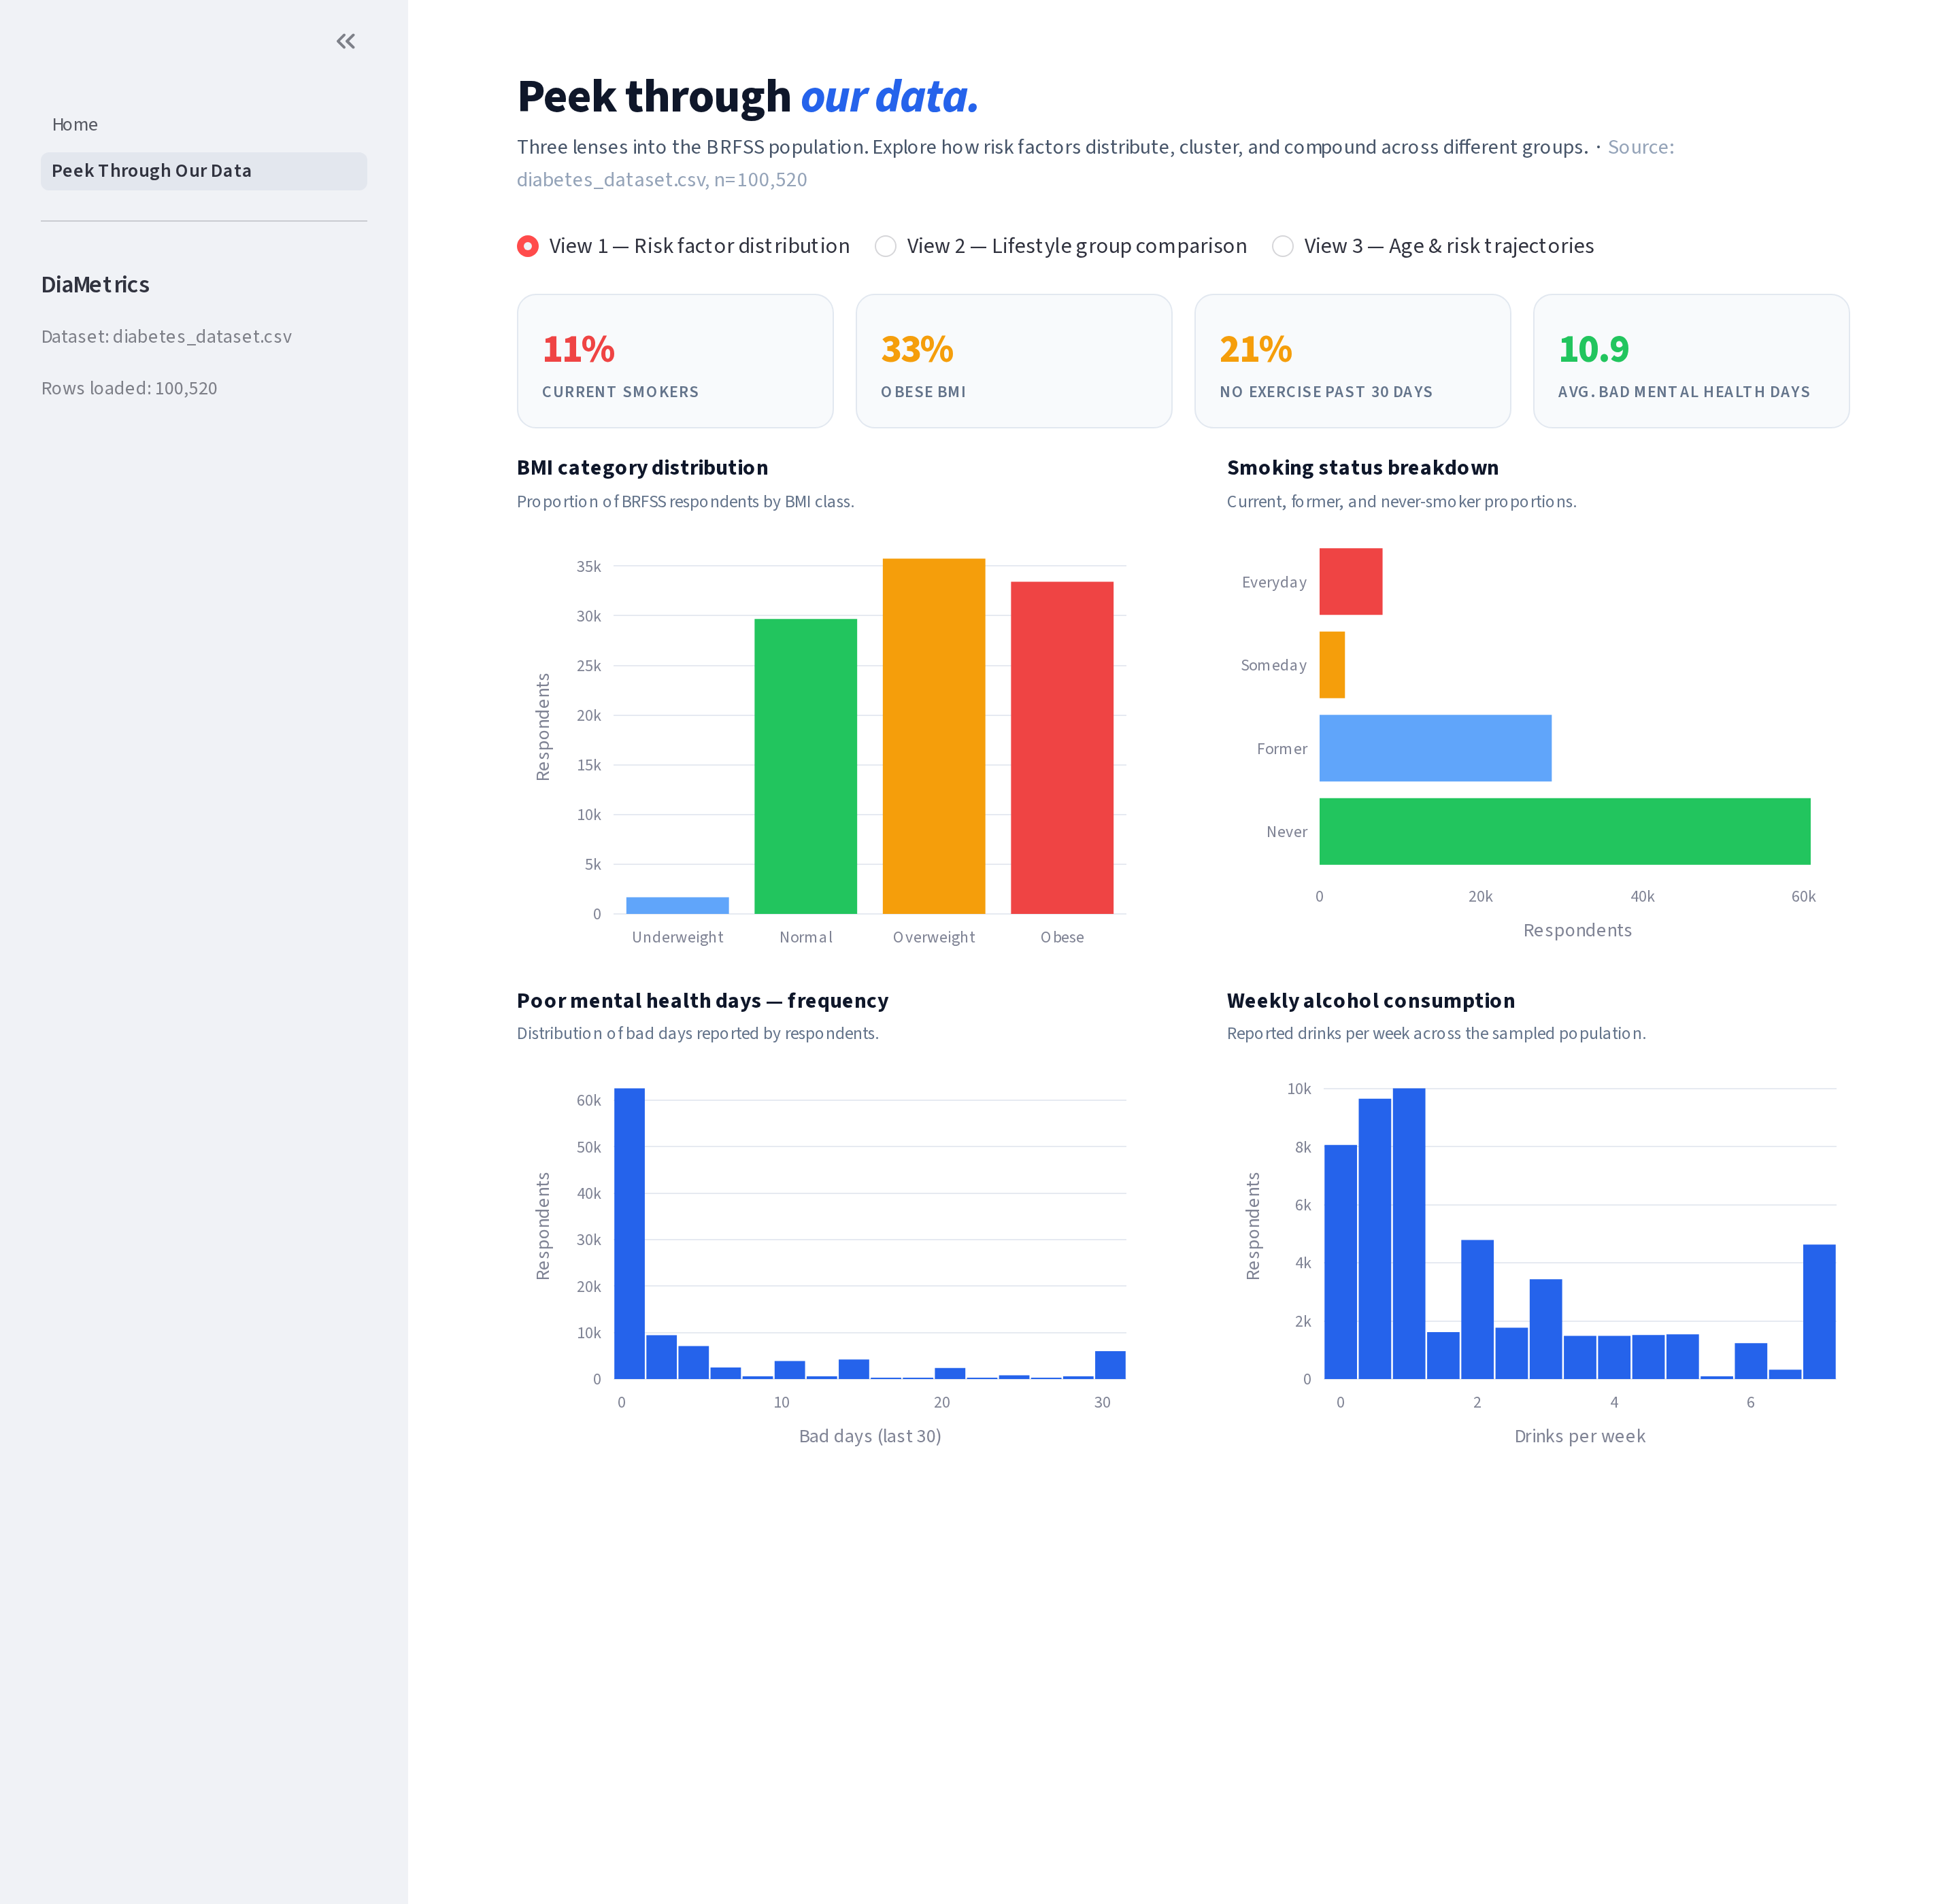
Fig 3. View 1: Risk factor distribution across BMI class, smoking status, mental health days, and weekly alcohol.
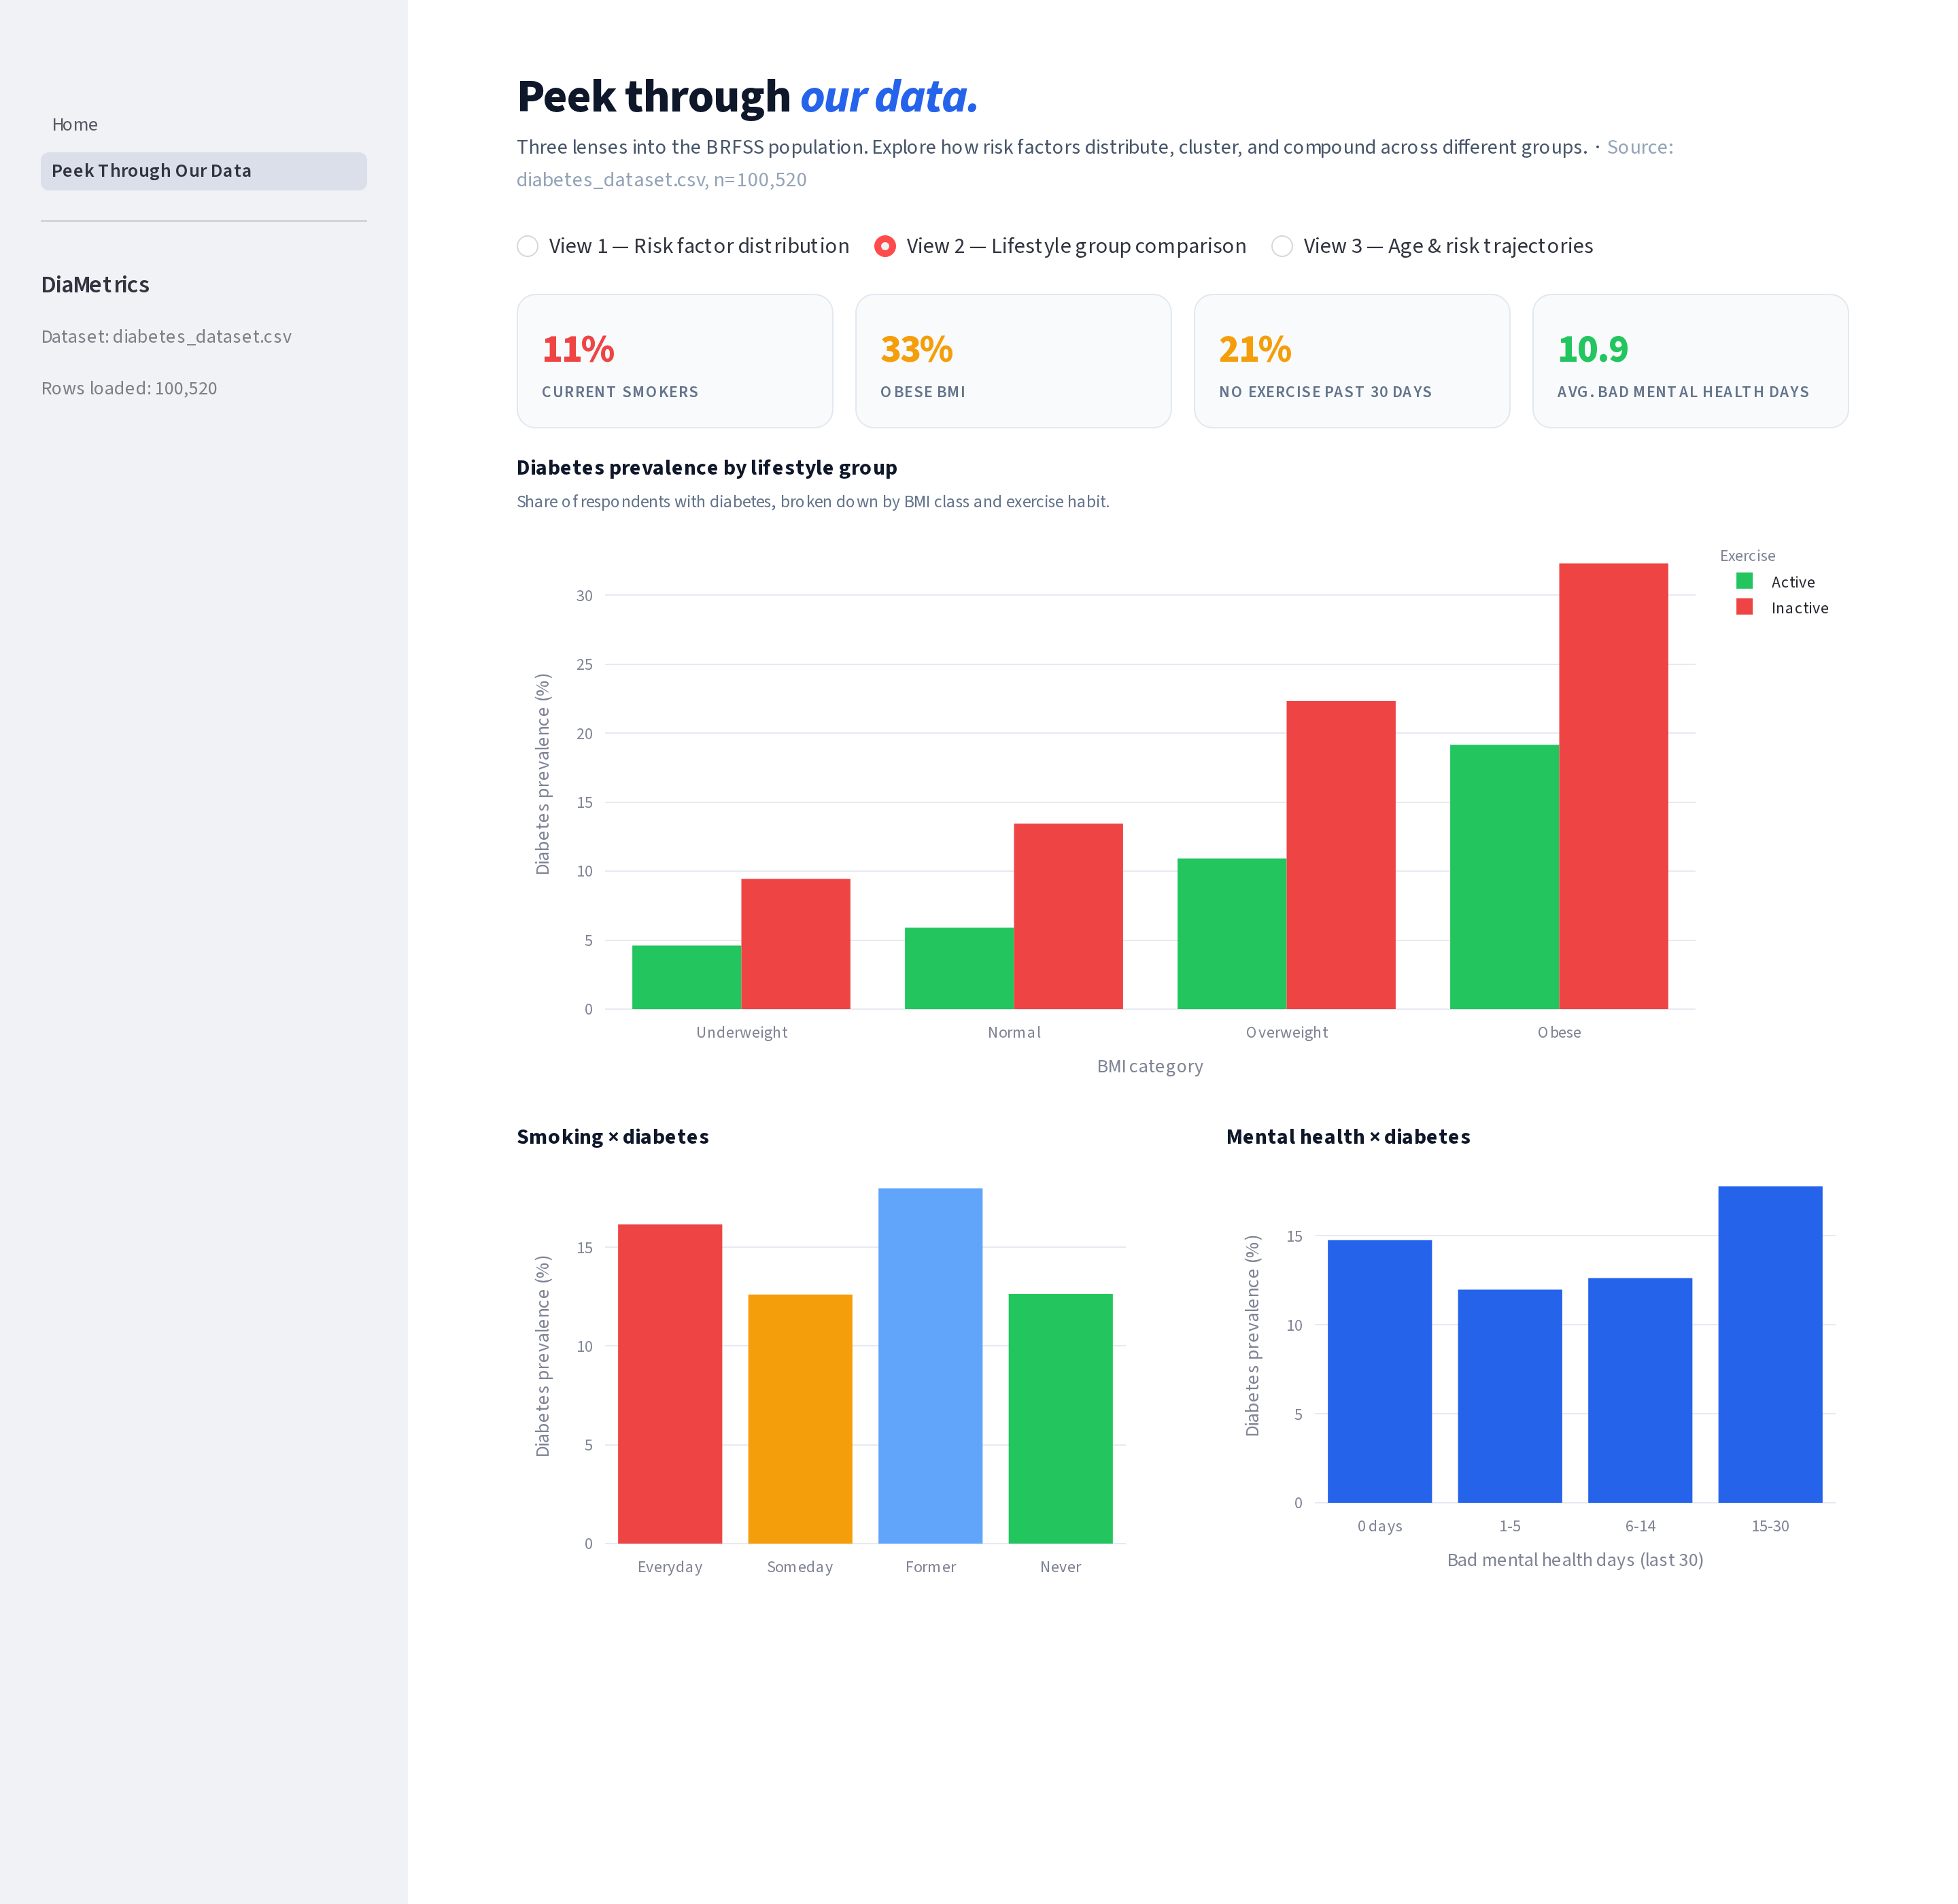
Fig 4. View 2: Diabetes prevalence grouped by BMI × exercise, smoking, and mental-health bands.
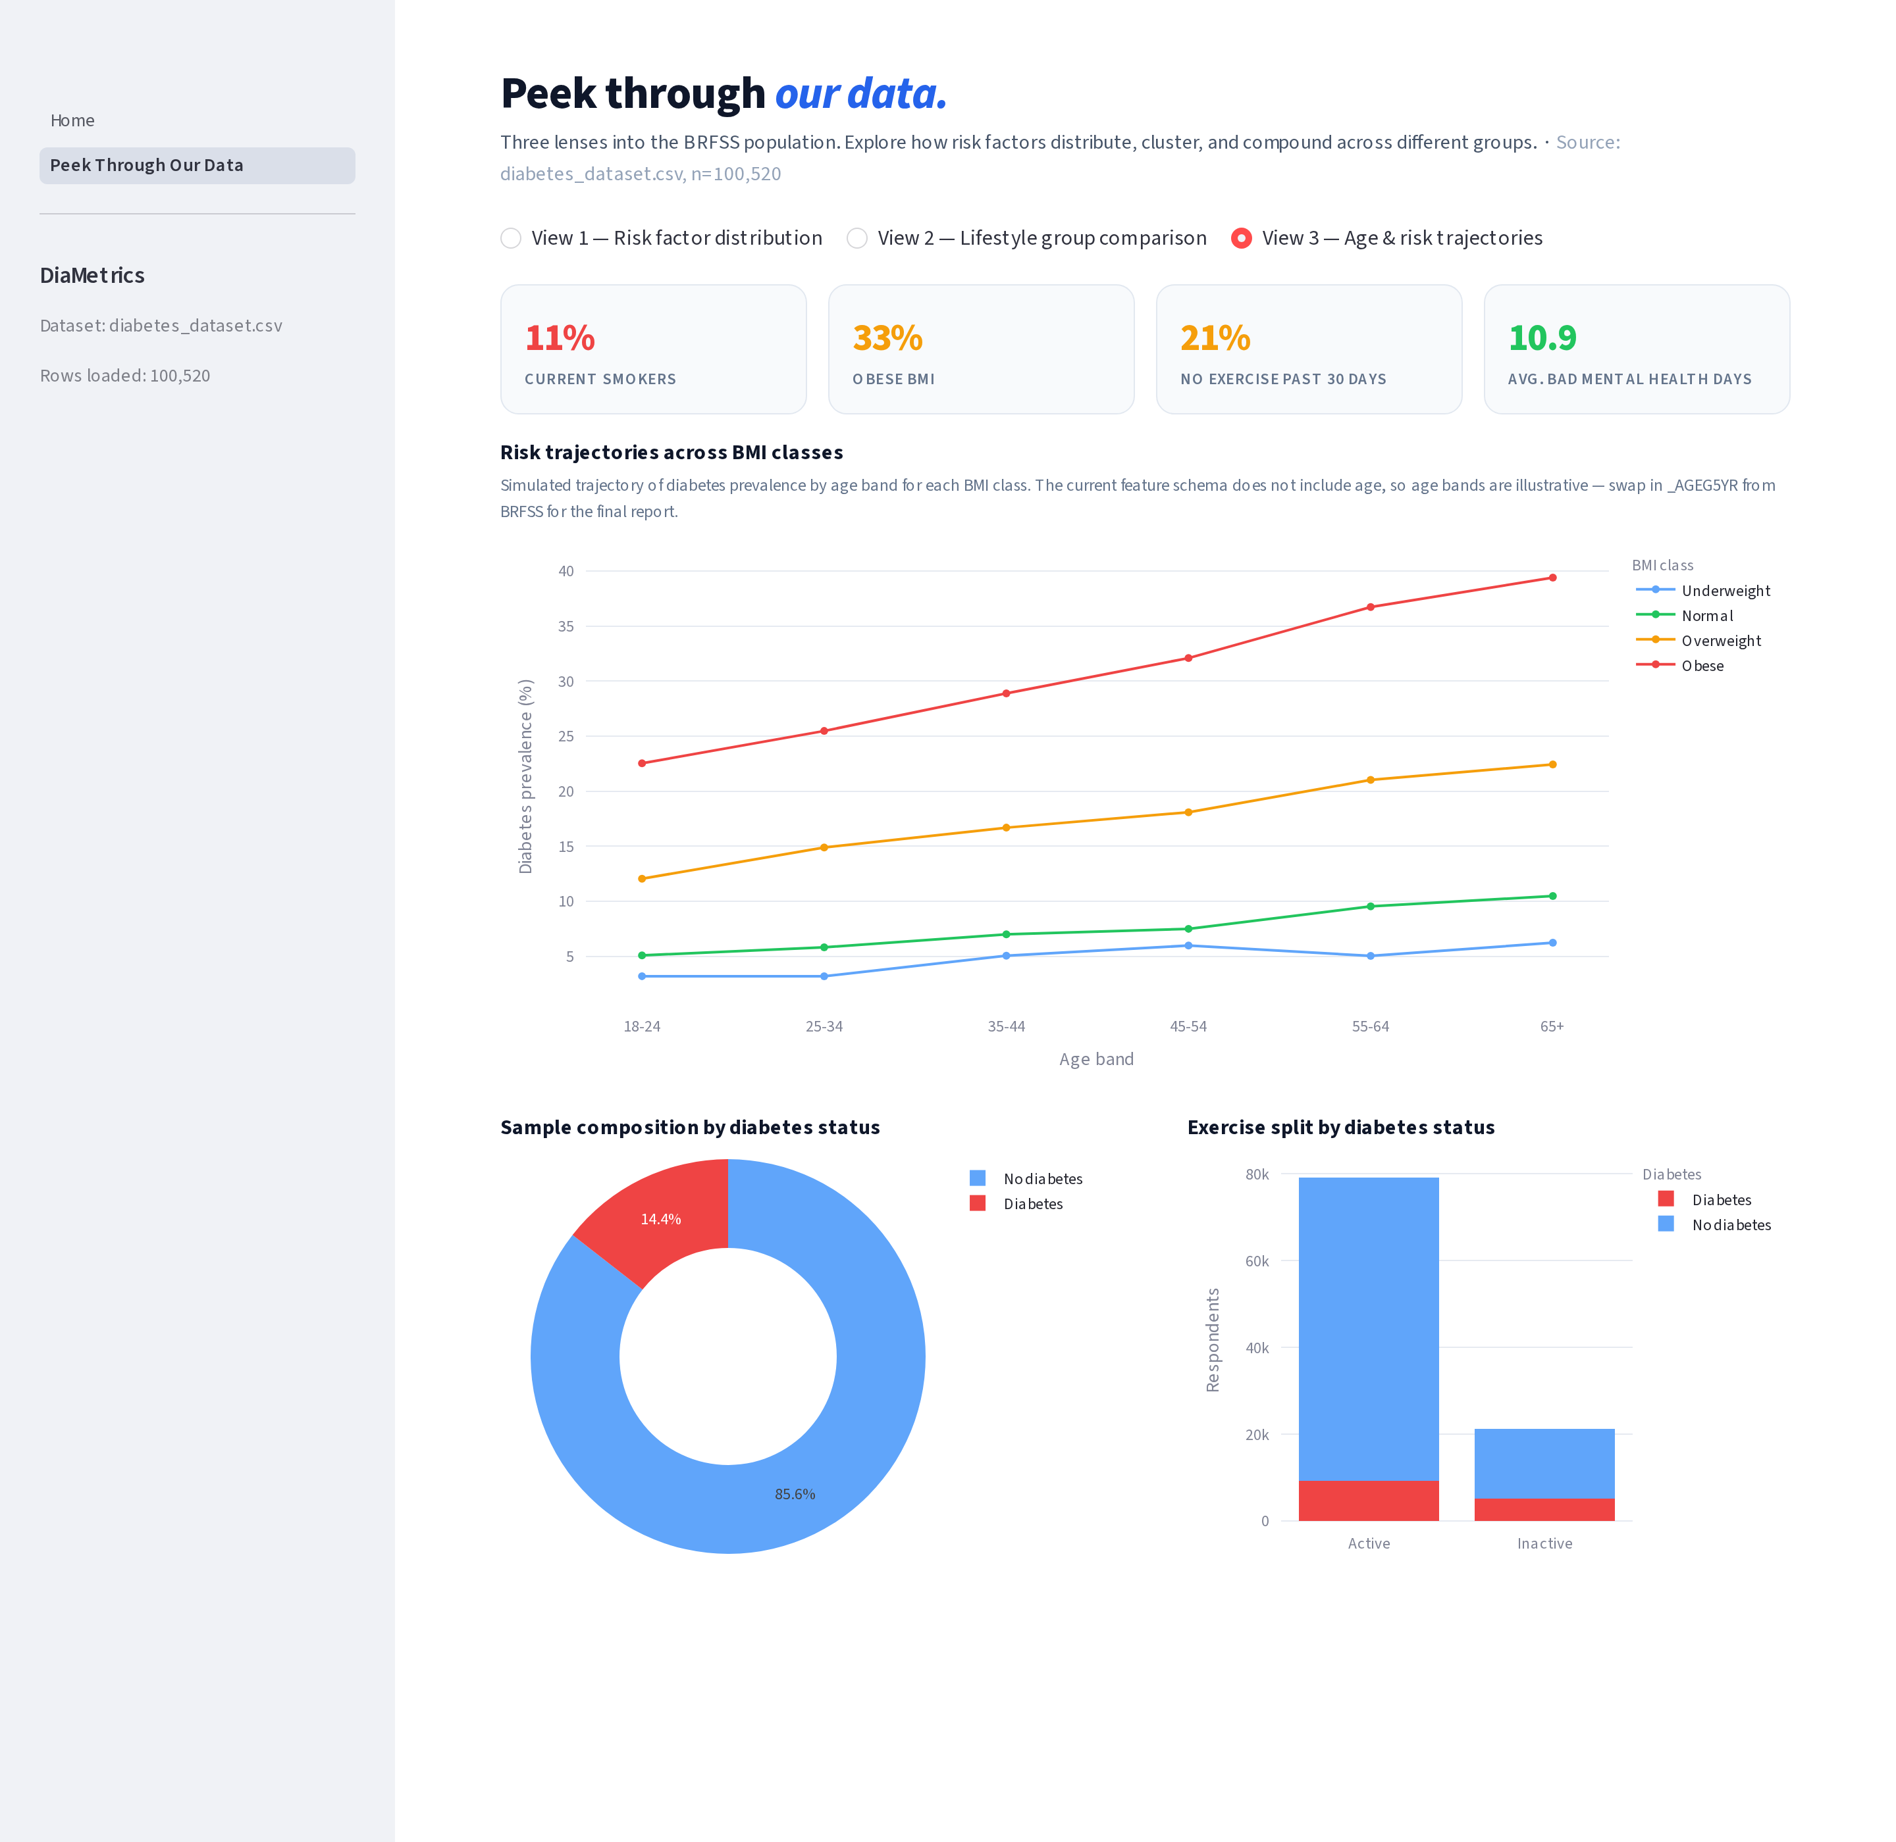
Fig 5. View 3: Risk trajectories across BMI classes by age band, with sample composition and exercise split.

Page 2 — Model Playground
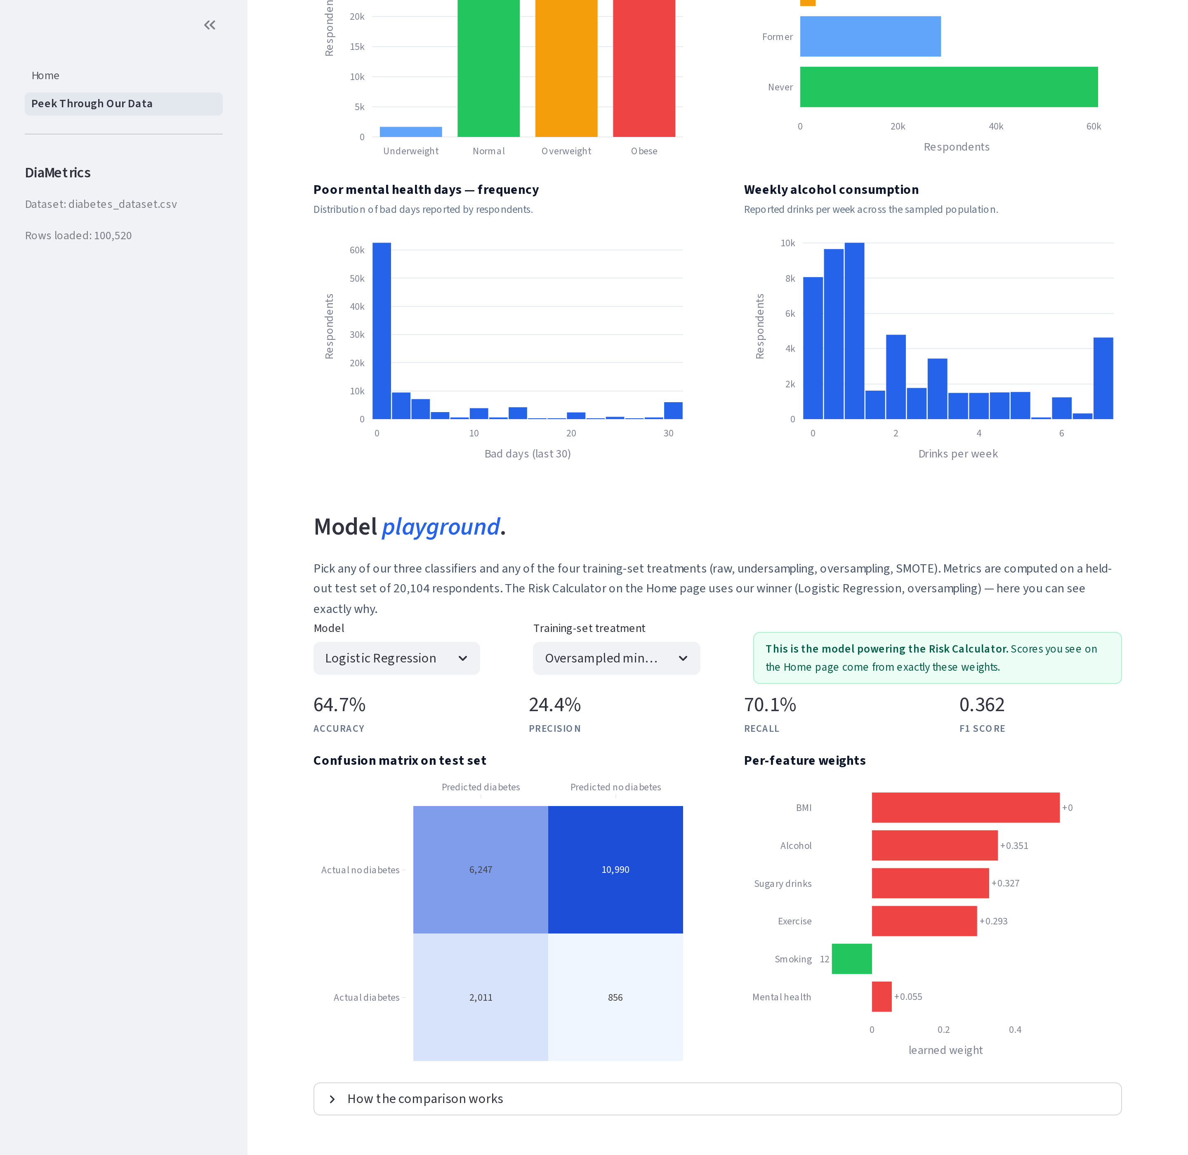
Fig 6. Page 2 Model Playground. Users can pick any of our three classifiers (Logistic Regression, SVM, Naive Bayes) and any of the four training-set treatments (original, undersampling, oversampling, SMOTE) and see test-set accuracy, precision, recall, F1, confusion matrix, and per-feature learned weights. Shown: the deployed winner — Logistic Regression + oversampling (acc 64.7 %, prec 24.4 %, recall 70.1 %, F1 0.362).

2. Instructions to run the Streamlit code
Tested on macOS and Linux with Python 3.10+. Windows follows the same steps with the venv activation line swapped out (noted below).
- Clone the repo and move into the app folder:
git clone https://github.com/maria-decaro/PAML_final_project.git
cd PAML_final_project/DiaMetrics
- (Recommended) create and activate a virtual environment:
python3 -m venv .venv
source .venv/bin/activate # macOS / Linux
.venv\Scripts\activate # Windows PowerShell
- Install dependencies:
pip install -r requirements.txt
- Launch the Streamlit app:
streamlit run Home.py
Streamlit prints a local URL (default http://localhost:8501). Open it in a browser. Use the left sidebar to switch between “Home” (Personal Risk Calculator) and “Peek Through Our Data” (BRFSS explorer).
- To stop the app, press Ctrl+C in the terminal. To run on a different port: streamlit run Home.py --server.port 8502.

Notes for the team
- Feature schema exactly matches the team contract: EXERANY2, _BMI5CAT, _SMOKER3, MENTHLTH, SSBFRUT3, ALCDAY4 → DIABETE4.
- The risk score is computed by a placeholder clinically-weighted scorer in utils/predictor.py. Max’s LR (or Maria’s SVM / Rhia’s NB) can be swapped in by replacing the body of predict_risk — the return contract is the same. Full guide is in the README.
- Dataset source: data/diabetes_dataset.csv (cleaned BRFSS 2024 extract from Nina’s preprocessing, 100,520 rows). If missing, the app falls back to a synthetic sample so the UI still renders.

